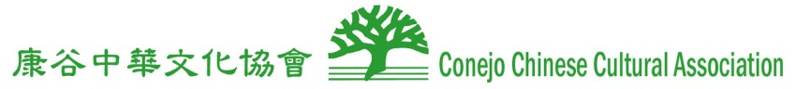
http://www.ccca-tocs.org/ SCofCCCA@gmail.com
Event Proposal
Name of Organization | Student Commission (SC)  Conejo Chinese Cultural Association (CCCA)
Event | 2 hours of Chinese cultural enrichment program
Available Dates | Any day between Aug. 1 to Aug. 8, 2016
Time | Either morning or afternoon
Proposed Camp | Conejo Valley USD | University Center summer camps
Volunteers | ~ 10 CVUSD high school students and 2 adults from the Student Commission of the CCCA
Program Description | Chinese face changing art, Chinese yoyo, calligraphy, origami, shuttlecock, chopstick competition, and cultural displays
5 minutes presentation | Why it is important to learn about different cultures?  America is a ‘melting-pot.’  It is an era of a global society.  Everyone need to strengthen the bond of the community.
Station 1 | Calligraphy, origami
Station 2 | Chinese stories with various demonstrations and displays
Station 3 | Chopstick demonstrations and competitions
Station 4 | Shuttlecocks and Chinese yoyo
Benefits | Participating in a cultural enrichment program could be a life changing experience. It not only broadens the volunteer students and the campers’ point of view but also provides opportunities to gain new skills and knowledge.  Starting to embrace cultural diversity and racial inclusion at young age
Camper Learning Outcome | Program has an aim of helping to increase the camps' understanding and curiosity of other cultures, as well as igniting their desires to learn other languages and broadening their social horizons.
Student Commission Chair | Benjamin Yang 8050490-5406  Benyang55@yahoo.com
Student Commission  Supervisor | Wen Chien 818-857-2711  wchien@sbcglobal.net
iv

