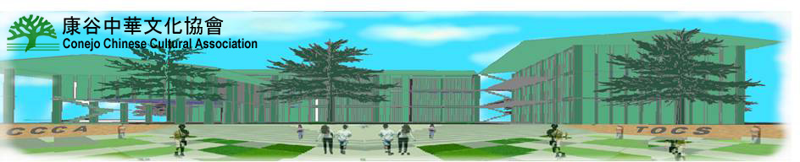

The Conejo Chinese Cultural Center Project

The Conejo Chinese Cultural Center is a major project undertaken by the Conejo Chinese Cultural Association (CCCA).

The Missions for the Chinese Cultural Center are:
- A facility for sharing Chinese culture with exhibits, special events, lectures, and social activities.
- A vibrant community center for everyone in the Conejo Valley area who are interested in Chinese heritage, language, and culture.
- A dedicated campus for the Chinese language school programs and other educational functions.

The Chinese population in the Conejo Valley has steadily increased every year. It becomes evident that an education and activity center (The Center) is needed for serving this community. With the increasing global trading, political interface, and cultural exchanges, more and more non-Chinese local residents are interested in learning Mandarin Chinese, exploring rich Chinese heritage, and understanding Chinese culture. The Center will provide equal services to local residents regardless of their race, color, political stand, and national origin.

The Center will be in the Conejo Valley area, and serve the communities including, but not limited to: Camarillo, Newbury Park, Thousand Oaks, Moorpark, Simi Valley, Westlake Village, Oak Park, Agoura Hills, most of Ventura County, and west Los Angeles County.

The Cultural Center program is implemented in three phases: Phase I is to establish a cultural center in a leased facility. Phase II is to build/own a property for the Cultural Center activities. Phase III is to expand by including a Chinese school at The Center. We are in the Phase I now. Actual timings for Phase II and III will depend on the funding availability.

The funding will come from the following sources: CCCA savings, organization sponsorships, individual donations, bank loans, and private loans.

If you are willing to participate in the Cultural Center planning and implementation process, please send email to: ccpc@ccca-tocs.org., or check the CCCA website at: http://www.ccca-tocs.org.

For monetary donations (tax deductible), please make your check payable to Conejo Chinese Cultural Association and mail it to P.O. Box 6775, Thousand Oaks, CA 91362. On the check please specify: “Cultural Center Fund”.

Let’s work together to support this significant project for the community!

